Synoptic chart worksheet
Complete the following instructions on the images on the next page. Then complete the questions about the charts.

- On Chart A, colour the low pressure system with the strongest wind.

- On Chart A, draw the direction of the wind in the low, off North Queensland.

- On Chart B, indicate the direction you expect the high pressure system to move in over the next three days.

- On Map C, draw the wind direction arrows for the high over Queensland and the low off the Queensland coast.

- On Map D, draw isobars to show increased wind strength around the low in the Northern Territory.

- There is a strong wind warning being produced by a low off the coast of New South Wales — draw a low pressure system on Map E to show this.

- Map F shows isobars and wind direction but the low and high pressure systems are not labelled. Label them.

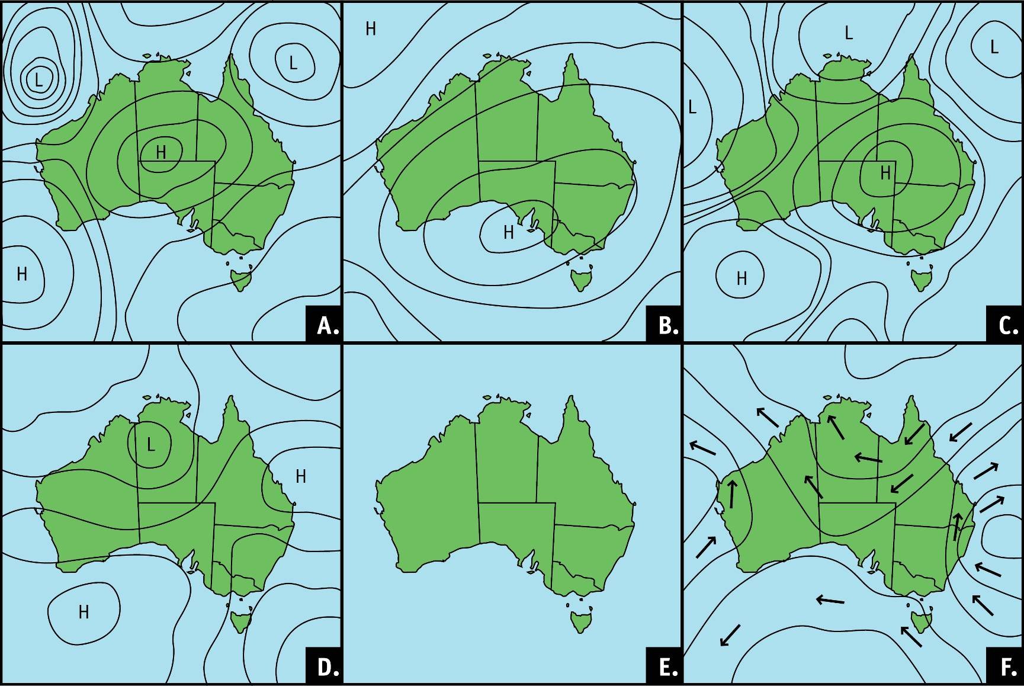

Use the charts to answer the following questions. Remember to use your scientific knowledge and language to answer the questions.
- Which map would most likely produce fine weather conditions over the whole country? Explain your reasoning.

- Would weather be ideal for an outdoor event in Queensland according to Map D? Why/Why not?

- Predict what kinds of weather conditions could be expected in the northern part of Western Australia on Map A.

- List additional research that would improve the accuracy of this prediction.

- Justify how this additional research can be used to create a more accurate prediction.

